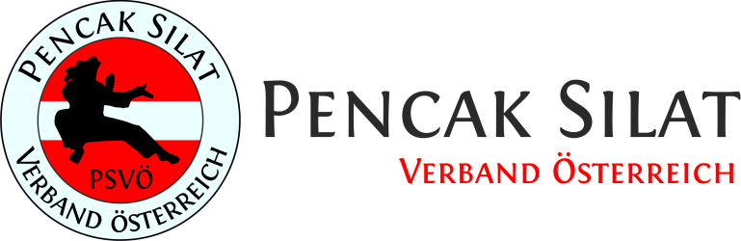
Information
Pencak Silat Austrian Open and
Indonesian Ambassadors Cup 2017

Organizer:

PSVÖ Pencak Silat Verband Österreich
Stefan Taibl + Eduard Linhart
c/o: Silat Akademie
Währinger Gürtel 29, 1180 Wien
www.psvoe.at, office@psvoe.at
Date:

Saturday, June 24th 2017
9 a.m. until 8 p.m.

Exact schedule will be fixed after registration deadline / subject to changes

Deadline for registration: Monday, 5th June 2017

Participation fee: 30 EUR / first category, 15 EUR / each further category

Participation in the Austrian Open is restricted to clubs which are member of the European Pencak Silat Federation (EPSF), maximum number of participants in total is 80.

The best athletes will be honoured by the Indonesian Embassy!
Location:
ASKÖ Ballsport Center

Bernoullistraße 7-9
1220 Wien

The organizer does not provide any transportation or accomodation. In the vicinity of the location are several hotels, a large shopping mall (open on Saturday until 6 p.m.) and a Cineplexx cinema with restaurants and other facilities.
The venue can be reached with metro line U1. There is a good connection to the city highway.

All competitors have to wear dresses with long sleeves and long trouser legs.

Categories:

Age categories:

A: 8 – 10 years
B: 11 – 13 years
C: 14 – 16 years
D: 17 – 35 years
E: 36 years and older

Each category is split in male and female subcategories.

In case of less than two participants per category, categories will be merged. This is at the discretion of the organizer.

Participation is at the participant‘s own risk.

Tanding / full contact:
Children should use protectors (shin, gloves, etc). Teenagers may use protection. For adults protection is limited to body protection and cup.

A1: 8 – 10 years:
2 rounds at 1.5 minutes, 1 minute break – 3 kg weight difference

B1: 11 – 13 years:
3 rounds at 1.5 minutes, 1 minute break – 3 kg weight difference

C1: 14 – 16 years:
3 rounds at 2 minutes, 1 minute break – 5 kg weight difference

D1: 17 – 35 years:
3 rounds at 2 minutes, 1 minute break – 5 kg weight difference

E1: 36 years and older:
3 rounds at 2 minutes, 1 minute break – 5 kg weight difference

Seni / forms:

Free form:

8 – 10 years:
A2: 1.5 minutes without weapons
A3: 1.5 minutes with weapons

11 – 13 years:
B2: 2 minutes without weapons
B3: 2 minutes with weapons

14 – 16 years:
C2: 3 minutes without weapons
C3: 3 minutes with weapons

17 – 35 years:
D2: 3 minutes without weapons
D3: 3 minutes with weapons

Tunggal (single):

A4: 8 – 10 Jahre (only without weapons)
Maximum 2 minutes (2.01-2.15 minutes results in 5 points deduction, 2.16-2.30 10 points deduction, above 15 points)

B4: 11 – 13 years
C4: 14 – 16 years
D4: 17 – 35 years

Ganda (double):

A5: 8 – 10 years: 1.5 minutes
B5: 11 – 13 years: 2 minutes
C5: 14 – 16 years: 3 minutes
D5: 17 – 35 years: 3 minutes

